**INSTALLATION GUIDE**

**CONTENTS**

1. Package Contents

2. System Requirements

3. Key Features

4. Installation and Setup / Registration / Technical Support

5. Configuring Your Razer Hydra

6. Using Your Razer Hydra

7. Troubleshooting

8. Legalese

.

**PACKAGE CONTENTS**

- Razer Hydra PC Gaming Motion Sensing Controllers

- Base Station

- USB Cable

- Quick Start Guide

**SYSTEM REQUIREMENTS**

- PC with USB port

- Windows® 7 / Windows Vista® / Windows® XP

- Internet connection (for driver installation)

- 75MB of free hard disk space

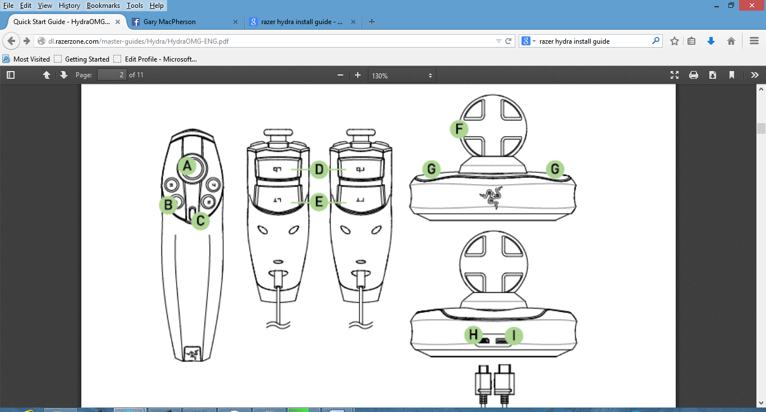

**A.** Analog Stick/Button 6

**B.** Buttons 1 - 4

**C.** Button 5

**D.** Bumper Buttons

**E**.Trigger Buttons

**F.** Base Station

**G.**Controller Holder

**H**. PC Connector

**I.** Controller Connector

**INSTALLATION AND SETUP**

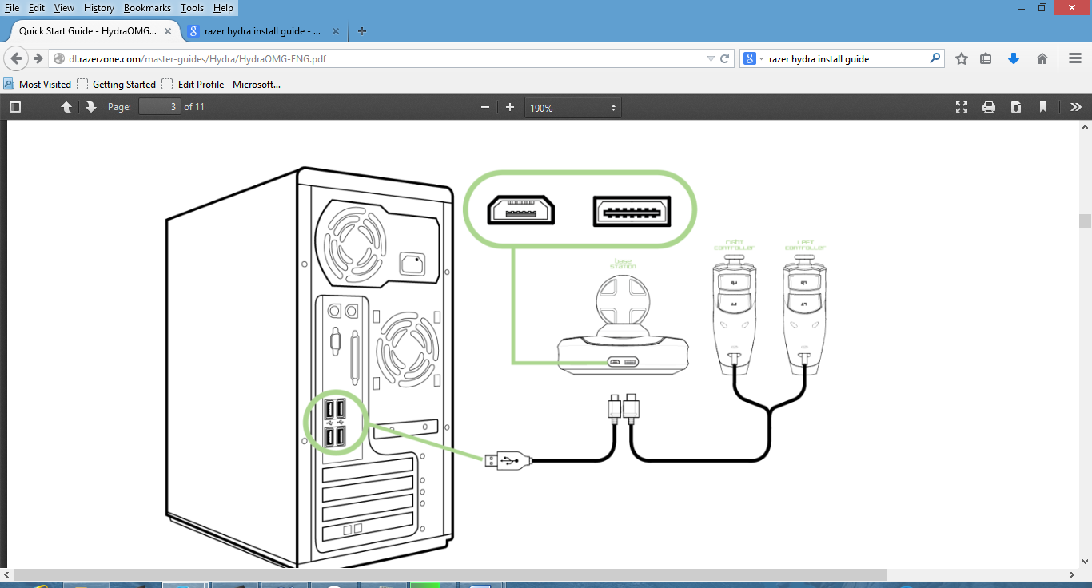

**1.** Plug in the controller cable to the base station.

**2**. Plug in the USB cable to the base station and your PC.

**3.** Download the driver installer at www.razersupport.com

**4.** Run the installer and follow the onscreen instructions.